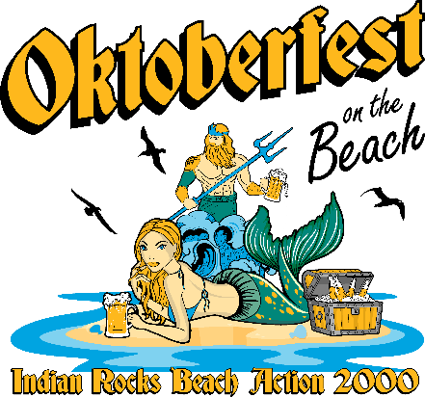

IRB Action 2000 (A2K), in partnership with the City of Indian Rocks Beach, is thrilled to announce our 23rd Annual Oktoberfest on the Beach, happening Saturday, October 11, 2025, from 12 PM to 6 PM at Kolb Park!
Sponsoring Oktoberfest 2025 is a great opportunity to connect with a large, engaged audience, boost your brand visibility, and show your support for our vibrant coastal community.
As a nonprofit organization, A2K is dedicated to preserving the unique charm and character of Indian Rocks Beach. In the aftermath of Hurricane Helene, our mission is more important than ever. With your support, we can continue important community projects that enhance and beautify our town.
Your sponsorship helps fund a wide range of initiatives—from park maintenance and public art installations to historic preservation efforts and popular community events. We invite you to visit www.irbaction2000.com to see the difference we’re making, including updates on ongoing projects.
Thank you for your time and consideration. We look forward to seeing you at Oktoberfest 2025 and hope you’ll be part of another unforgettable event!
Sincerely,

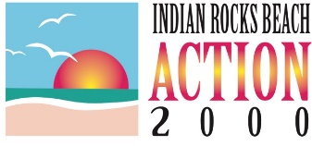
Mia Stierheim Earl Wesson Scotti Vaughan
Oktoberfest Sponsorship Oktoberfest Sponsorship Oktoberfest Sponsorship
(305) 345-9808 (813) 220-8589 (727) 644-0633
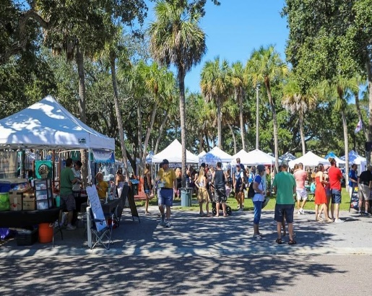
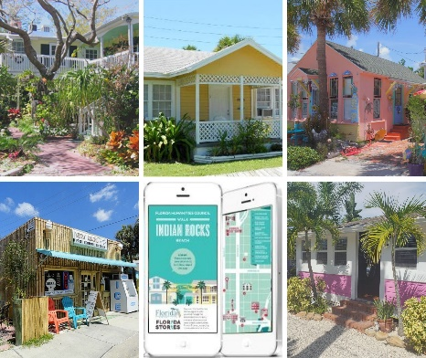
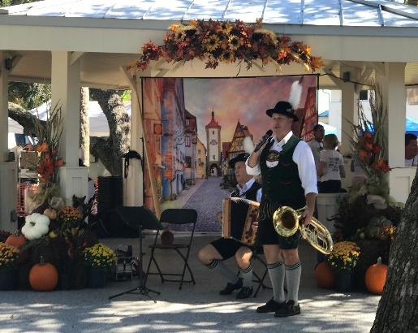
mia.stierheim@gmail.com ewesson@tampabay.rr.com scottivaughan@hotmail.com

